RACE INSTRUCTIONS
Venue
The start and finish will be near Race HQ which is trackside at Lewes Leisure Centre, Mountfield Road, Lewes, BN7 2XG. Please follow signs to walk to the back of the building rather than through the Leisure Centre
Date
The race takes place on Monday 6 April 2026
Race start times
10k Race - 10.45 am
Junior 1 Mile Race - 10.15 am
Toddlers Trot 400m - 10.00 am
Course
10k
Starts on the running track, leaves the track area and is essentially a largely flat loop south of Lewes to the village of Iford on a multi-terrain course comprised mainly of bridleways and foot paths with a short section of road through Iford village, finishing back at the track. The majority of the course is surfaced, either gravel path, pavement or tarmac. Please note care should be taken on the first section of Ham Lane soon after you set off and pass the second pair of marshals outside the tip - while the potholes have recently been topped up, the road surface is still uneven in parts. Shortly after there is a short section on the bridleway between the sometimes sodden fields towards Iford which can be muddy. After that section the remainder of the course is in good running condition. It is well signed and marshalled and comes in at a little over 10k. Map and link to GPS file below:
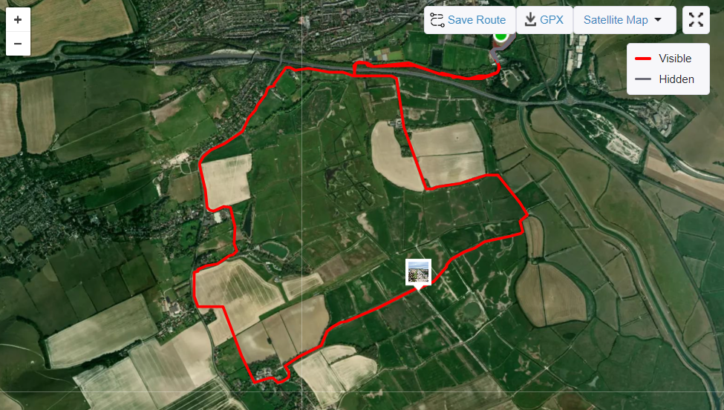
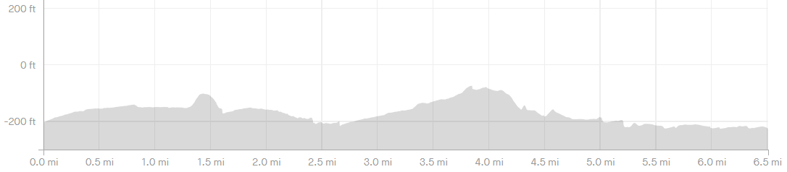
GPX file: LAC_Easter_Monday_fun_run_route.gpx
Junior race: Approximately 1 mile start time 10.15am
Starts on the running track takes a half mile detour out through the Priory School grounds and Ham Lane. Finishes back on the track.
Toddlers Trot: 400m start time 10am
One lap of the track
Logistics
Free car parking available in the designated carparks (which will be well-signed; please do not park at the Leisure Centre)
Refreshments at Race HQ, as are portaloos
Race Timing
Sport Systems will be timing the event using shoe timing chips.
We will provide runners with a “Race Time” calculated from when the race is started to when the runner crosses the finish – this is sometimes called gun time as well as a personal chip time.
The results and prizes will be based on Chip Time order.
Race Numbers, Chips and Race Information
Race numbers and chips need to be picked up on the day of the race. Please allow extra time to do this. Race specific information will also be available on the race website.
Headphones and MP3 Players
In line with WSFRL requirements, no headphones are permitted. You will be disqualified if you are found to be using them.
Where can I find the results?
The results for all WSFRL entrants will be uploaded to Smart Rs. Results will also be posted on the results section of www.sportsystems.co.uk shortly after the race.
Note: this event will be licenced by the TRA and will adhere to the UKA rules.
Good luck with your training and have a great run.
The Sport Systems Team and Kate Seymour, LAC Easter Fun Run Race Director

